|  |  |
| --- | --- |
| **OCN NI Use Only** | |
| **Q** | **Mark** |
| 1a |  |
| 1b |  |
| 1c |  |
| 1d |  |
| 1e |  |
| 1f |  |
| 1g |  |
| 2a |  |
| 2b |  |
| 2c |  |
| 2d |  |
| 2e |  |
| 2f |  |
| 2g |  |
| 3a |  |
| 3b |  |
| 3c |  |
| 3d |  |
| 3e |  |
| 3f |  |
| 3g |  |
| 3h |  |
| Total |  |

**OCN NI Level 1 Certificate in Essential Skills - Application of Number**

**Learner name ________________________________**

**Learner registration number ____________________**

**Learner signature _____________________________**

**Centre ______________________________________**

**Assessment Date ______________________________**

**Instructions to candidates:**

**You should have the following for this assessment:**

* Pen with black or blue ink
* Pencil and eraser
* 30 cm ruler
* Calculator
* Protractor

You may use a calculator.

**General Instructions:**

* There are 3 tasks to complete
* You must attempt all tasks
* Each task is worth 15 marks
* Read through each task carefully
* Show your working out; you may get marks for it
* Write all your working out and answers in this booklet
* Check your calculations
* Remember to put units on your answers
* Total marks available: **45**
* You have **1½ hours** to finish the assessment.

**Raising money for Charity**

**Task 1 – The Bake Sale**

Two groups of students organised a bake sale.

Group A sold cupcakes at break time.

Money raised for charity

|  |  |
| --- | --- |
| Day | Money raised |
| Monday | £33.50 |
| Tuesday | £42.50 |
| Wednesday | £43.00 |
| Thursday | £37.50 |
| Friday | £40.00 |

**1a** On which day was the most money raised? **(1 mark)**

**1b** If each cupcake costs 50p, how many cupcakes were sold on Wednesday?

Show your working. **(2 marks)**

**1c** Sam estimated that the students would raise at least an average (mean) of £35 per day.

Was Sam’s estimate correct? **(3 marks)**

Show your working.

**1d** Complete the bar chart to show how much money was raised on Friday.

**(1 mark)**

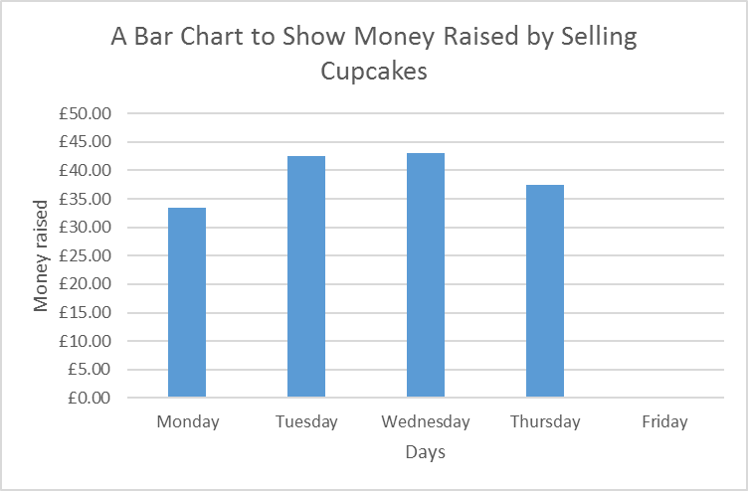

Group B made shortbread.

Shortbread recipe

300g plain flour

200g butter

100g sugar

The recipe makes 24 pieces of shortbread.

Flour comes in bags of 1.5kg.

Sugar comes in bags of 1kg.

Fay measured out 800g of butter.

**1e** How many bags of plain flour will she need? **(3 marks)**

Show your working and explain your answer.

The students made 96 pieces of shortbread each day.

On Monday, Jack dropped the box.

¼ of the pieces of shortbread broke and could not be sold.

**1f** How many pieces of shortbread were left to sell? **(2 marks)**

Show your working.

Group B sold one piece of shortbread for 30p.

At the end of the week, they had sold 443 pieces of shortbread.

The ingredients cost £17.00.

Group A gave £150 to charity.

**1g** Was this more or less than Group B? **(3 marks)**

Show your working and explain your answer.

**Task 2 – The Sponsored Walk**

Kate and Tom organised a sponsored walk.

One lap of the park is 5200 metres.

The arrows show the direction the students walked.

**2a** How many kilometres did the students walk? **(1 mark)**

km

Kate and Tom provided the students with water at the picnic area (marked P on the map).

The picnic area is 2900 metres from the start.

After completing the walk, Ben returns to help Kate and Tom pack up. He takes the shortest path to the picnic area and carries a box back to the finish.

**2b** Ben says that he has walked 10400m in total.

Explain why this is incorrect. **(4 marks)**

Show your working.

The students started their walk at 09:30am.

Kate finished at 11:25am.

**2c** How long did she take to complete the walk? **(2 marks)**

Show your working.

Hours mins

The first student to complete the walk took 60 minutes.

The last student to complete the walk took 145 minutes.

**2d** What was the range in times? **(1 mark)**

mins

Kate gave every student who took part a T-shirt.

She bought 80 T-shirts.

The sizes of T-shirts are shown in the table.

**2e** Complete the table: **(2 marks)**

|  |  |  |  |  |
| --- | --- | --- | --- | --- |
| Size | Small | Medium | Large | Extra Large |
| Percent | 10% |  | 25% | 15% |
| Fraction | $\frac{1}{10}$ | ½ | ¼ |  |

Two girls and nine boys request **extra-large** T-shirts.

**2f** Does Kate have enough **extra large** T-shirts? **(4 marks)**

Explain your answer.

Show your working.

**2g** Show one way of checking your calculation in question 2f. **(1 mark)**

**Task 3 – The Cake Raffle**

Emily wanted to bake a cake for charity.

She asked **12 friends** what type of cake she should bake.

Their responses are shown in the pie chart.

**3a** Estimate how many friends liked lemon cake best. **(1 mark)**

**3b** Estimate how many friends liked carrot cake best. **(2 marks)**

Show your working.

Emily used an American cookbook for the recipe.

The recipe said to bake the cake at 350ºF.

Emily assumed this was about 200ºC.

**3c** Was Emily’s assumption correct? **(2 marks)**

Give a clear justification for your answer.

Emily iced the top of the cake.

25 cm

25 cm

12 cm

The top of the cake is a square with sides 25 cm.

**3d** Calculate the area of the cake that Emily iced.

Use the formula: *Area = length x breadth*

Show your working. **(1 mark)**

cm²

Emily has bought 2m of ribbon to decorate the cake.

25 cm

25 cm

12 cm

She wanted to tie the ribbon around the cake.

She also wanted to make a bow using 20cm of ribbon.

**3e** Does Emily have enough ribbon? **(4 marks)**

Show your working and explain your answer.

Emily sold raffle tickets.

She sold 150 raffle tickets to students and teachers.

Peter bought 5 tickets.

**3f** What is the probability that Peter will win the cake? **(1 mark)**

Circle the correct answer.

$\frac{5}{15}$**5:150 0.30 $\frac{1}{30}$**

Emily sold a strip of 5 tickets for £1 or 1 individual ticket for 30p.

She kept a record of the tickets that she sold.

|  |  |  |
| --- | --- | --- |
| **Tickets** | **Tally** | **Frequency** |
| Strip of 5 tickets | ~~llll~~ ~~llll~~ ~~llll~~ ~~llll~~ lll | 23 |
| Individual tickets | ~~llll~~ ~~llll~~ ~~llll~~ ~~llll~~ ~~llll~~  ~~llll~~ ~~llll~~ | 35 |
|  | **Total tickets sold** | **58** |

**3g** Emily knows that she sold 150 tickets! **(2 marks)**

Explain why Emily’s table is incorrect.

Joe won the cake.

He decided to share the cake with Kate, Tom and Jack.

Each of the **four** students had the same amount of cake.

3h. Show two different ways that Joe could have cut the cake. **(2 marks)**